Asking for direction

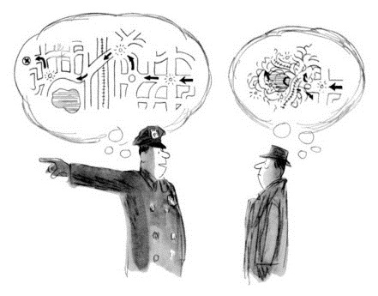

|  |  |  |
| --- | --- | --- |
| Excuse me | how can I get to ... | please? |
|  | where is ... |  |
|  | is ... near here |  |

Go straight ahead/on

Turn left/right

at the traffic light

It’s/Take the second (street) on the right/left

Pass ...

Cross the road

then

Sorry, could you say that again, please?

