What time is it?
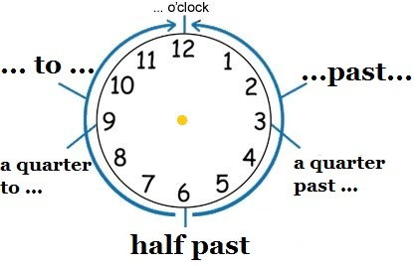

What time is it now (сейчас)?
It is ________________________________________________ .
It is ________________________________________________ .

What time is it?

What time is it now (сейчас)?
It is ________________________________________________ .
It is ________________________________________________ .

